A++ Computer Science IFS – Checker Board Lab Value - 999

Lab Goal: This lab was designed to help you learn how to use the powers of && and ! when writing your code to get the Jeroo to do what you want. && is the equivalent to “and” within a sentence. It can be used to compound conditions onto each other when using “while” or “if” statements to create a statement that will be more specific. ! is the equivalent to “not” and it is used to declare the opposite of a condition. For example, instead of writing isWater(AHEAD), which would cause the Jeroo to check if water is ahead, if you add ! to it and write !isWater(AHEAD) then the Jeroo will check if there is not water ahead.
Lab Description: This Lab requires you to use loops, unless you want to copy and paste a couple hundred times, to cause the Jeroo to create a checkerboard pattern across the entire island, as shown in Phase One, and then have the Jeroo clear the whole island picking up all the flowers. It is required you use && and ! atleast once within your code.
Files Needed:
Finalproject.jsc
And a blank island

Phase One:
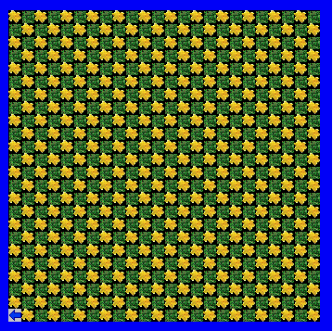
algorithm help

Preconditions
- Is there no water to my left?
- Is it clear to move ahead?
- Do I turn left or right?
- Should I hop and plant, or plant then hop, or does it not matter?

Postcondition
- The whole island is clear.
- Jeroo is in bottom left corner.
- Jeroo is facing West.
- Jeroo does not hop into the water.

Create a new pattern after the whole board is clear for extra points ; )

Ending Screen:
